Interpolation of seismic data using deep convolutional neural networks

**Introduction**

Our approach for interpolation of seismic data is directly linked to techniques within single image super-resolution, which aims at solving an ill-posed inverse problem, by recovering a HR image from its LR counterpart.

The data used in this project were downloaded from <http://software.seg.org/datasets/2D/1997_2.5D/>

**Theory**

**Convolution**

The mathematical operation of convolution is well known in image- and signal processing. Convolutions could be multidimensional and exist as an operation between two functions $A$ and $w$ in an n-dimensional framework. However, we will only deal with 2-dimensional discrete convolutions in this report. The 2-dimensional discrete convolution between $w$ and $A$ is defined as

$$w(x,y)*A(x,y)=\sum_{s}{\sum_{t}{w(s,t)A(x-s,y-t)}}$$

Let $w ∈R^{2×2}$ be a $3×3$ convolution kernel (also known as mask or convolution matrix), $A∈R^{2×2}$ an $2×2$ image and $H∈R^{2×2}$ the output from the convolution operation between $A$ and $w$.For this operation to be true, i.e. same size of input- and output image, we pad the input in both dimensions $A∈R^{4×4}$. This gives the following matrices

$$A_{pad}= \left[\begin{matrix}a_{0} & a_{1} & a_{2} & a_{3} \\ a_{4} & a_{5} & a_{6} & a_{7} \\ a_{8} & a_{9} & a_{10} & a_{11} \\ a_{12} & a_{13} & a_{14} & a_{15}\end{matrix}\right]$$

$$w= ⟦\begin{matrix}w_{0} & w_{1} & w_{2} \\ w_{3} & w_{4} & w_{5} \\ w_{6} & w_{7} & w_{8}\end{matrix}⟧$$

$$H= \left|\begin{matrix}h_{0} & h_{1} \\ h_{2} & h_{3}\end{matrix}\right|$$

Instead of dealing the convolution as a summation operation, we rewrite the convolution into a matrix-vector product

$$\hat{w}{\hat{A}}_{pad}=\hat{H}$$

In this case, the convolution kernel is reshaped to a matrix of size $\hat{w}∈R^{4×16}$ and the input is reshaped to a vector of size ${\hat{A}}_{pad}∈R^{16×1}$**,** which gives the output vector $\hat{H}∈R^{4×1}$. We see that writing the operation as matrix-vector product, we get a sparse transform of the convolution kernel as shown in (XXXXX)

$$\left[\begin{matrix}w_{0} & w_{1} & w_{2} & 0 & w_{3} & w_{4} & w_{5} & 0 & w_{6} & w_{7} & w_{8} & 0 & 0 & 0 & 0 & 0 \\ 0 & w_{0} & w_{1} & w_{2} & 0 & w_{3} & w_{4} & w_{5} & 0 & w_{6} & w_{7} & w_{8} & 0 & 0 & 0 & 0 \\ 0 & 0 & 0 & 0 & w_{0} & w_{1} & w_{2} & 0 & w_{3} & w_{4} & w_{5} & 0 & w_{6} & w_{7} & w_{8} & 0 \\ 0 & 0 & 0 & 0 & 0 & w_{0} & w_{1} & w_{2} & 0 & w_{3} & w_{4} & w_{5} & 0 & w_{6} & w_{7} & w_{8}\end{matrix}\right]\left[\begin{matrix}a_{0} \\ a_{1} \\ a_{2} \\ a_{3} \\ a_{4} \\ a_{5} \\ a_{6} \\ a_{7} \\ a_{8} \\ a_{9} \\ a_{10} \\ a_{11} \\ a_{12} \\ a_{13} \\ a_{14} \\ a_{15}\end{matrix}\right]=\left[\begin{matrix}h_{0} \\ h_{1} \\ h_{2} \\ h_{3}\end{matrix}\right]$$

Computing the output of a convolution operation between a $3×3$ kernel and an $5×5$ input giving an $3×3$ output is displayed in Figure (XXXXX). The convolution operation is a sparse and linear transformation, meaning that a few inputs contribute to the given output, and reuses the parameters such that the same weights are applied to multiple locations within the input (Dumoulin and Visin, 2016).

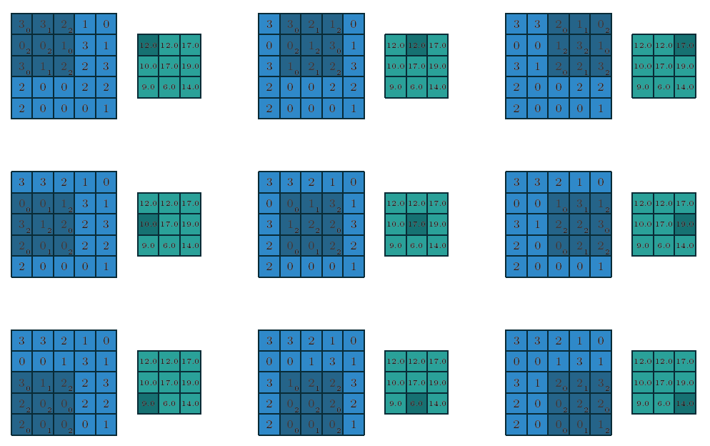

**Figure 1:** Computing the output of a convolution operation between a $3×3$ kernel (dark blue superimposed the blue image values) and a $5×5$ input (blue image values), giving a $3×3$ output (green image values). Dumoulin and Visin (2016).

**Strides and zero padding**

The convolution operation include some fundamental properties, which affect the output size of the convolution layer. These properties include (Dumoulin and Visin, 2016)

* $i_{j}$: input size along the axis $j$
* $k_{j}$: kernel size along the axis $j$
* $s_{j}$: stride along the axis $j$, which defines the distance between the pixels of consecutive kernel.
* $p_{j}$: zeros padding along axis $j$, which defines the number of added zeros concatenated at image boundaries.

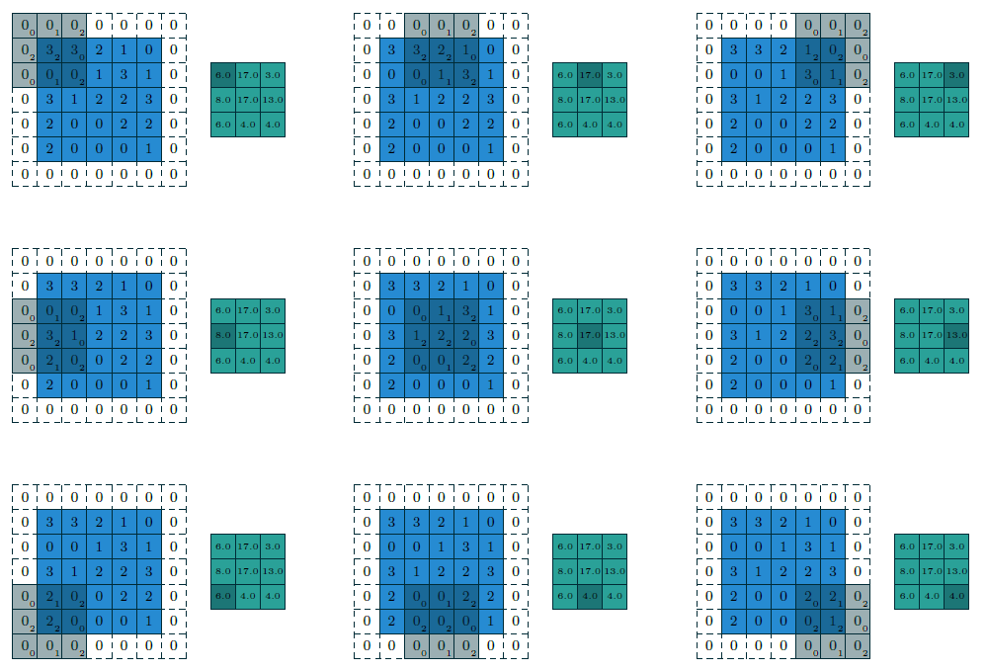The output size of an image $I$ is given by the relationship between the properties as follows

$$I=\left[\frac{i+2p-k}{s}\right]+1$$

**Transposed convolution**

In order to go from LR-space to HR-space, we can apply a convolutional operation known as transposed convolution (sometimes referred to as deconvolution in machine learning). We apply the transposed convolution layer for upsampling to the same pixel numbers as the target image. The transposed convolution operation between ${\hat{w}}^{T}∈R^{16×4}$ and input $\hat{H}∈R^{4×1}$**,** gives the output image $\hat{U}∈R^{16×1}$.

$${\hat{w}}^{T}\hat{H}=\hat{U}$$

$$\left[\begin{matrix}w_{0} & 0 & 0 & 0 \\ w_{1} & w_{0} & 0 & 0 \\ w_{2} & w_{1} & 0 & 0 \\ 0 & w_{2} & 0 & 0 \\ w_{3} & 0 & w_{0} & 0 \\ w_{4} & w_{3} & w_{1} & w_{0} \\ w_{5} & w_{4} & w_{2} & w_{1} \\ 0 & w_{5} & 0 & w_{2} \\ w_{6} & 0 & w_{3} & 0 \\ w_{7} & w_{6} & w_{4} & w_{3} \\ w_{8} & w_{7} & w_{5} & w_{4} \\ 0 & w_{8} & 0 & w_{5} \\ 0 & 0 & w_{6} & 0 \\ 0 & 0 & w_{7} & w_{6} \\ 0 & 0 & w_{8} & w_{7} \\ 0 & 0 & 0 & w_{8}\end{matrix}\right]\left[\begin{matrix}h_{0} \\ h_{1} \\ h_{2} \\ h_{3}\end{matrix}\right]=\left[\begin{matrix}u_{0} \\ u_{1} \\ u_{2} \\ u_{3} \\ u_{4} \\ u_{5} \\ u_{6} \\ u_{7} \\ u_{8} \\ u_{9} \\ u_{10} \\ u_{11} \\ u_{12} \\ u_{13} \\ u_{14} \\ u_{15}\end{matrix}\right]$$

**Sub-pixel resampling**

The sub-pixel resampling method is another approach for upsampling the image. According to Shi et al (2016) we can go from LR-space to HR-space with a periodic shuffling operation, which rearranges the input dimensions. The HR image is denoted (for any arbitrary layer) as follows

$$I^{HR}=f^{L}\left(I^{LR}\right)=PS(W^{\left[l\right]}*f^{l-1}\left(I^{LR}\right)+b^{[l]})$$

where $PS$ is the reshuffling operation that rearranges the elements of $I^{LR}∈R^{H×W×Dr^{2}}$ to $I^{HR}∈R^{rH×rW×D}$, which is illustrated in Figure XXXXXXX. For our CNN, the sub-pixel operation is handled by a **tensorflow** function, which is a slightly more generic version than the method explained in Shi et al (2016), and known as *tf.contrib.periodic_resample.* We also only consider the horizontal axis for image upscaling, which means we are going from $I^{LR}∈R^{H×W×Dr}$ to $I^{HR}∈R^{H×rW×D}$.

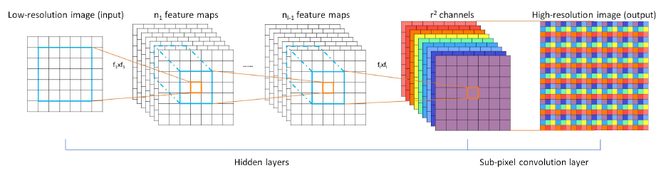

**Cost function**

**Parameter initialization**

In optimization problems, we initialize the weights $W^{[l]}$ to small random numbers and the biases $b^{[l]}$ commonlyto zeros. We initialize the variables in $W^{[l]}$ by the predefined function in **tensorflow** *tf.random.truncated_normal* with standard deviation $σ=0.1$. We experienced that the truncated normal distribution gave increased model performance (lower loss) than using regular normal distributed random variables.

**Adaptive gradient descent optimization**

For the super resolution problem, we apply first order gradient-based optimization methods in order to train our model. We start by denoting the parameters (or weights) at the $t$- $th$ iteration as ${ W}_{t}^{\left[l\right]}$, giving the updating rule for gradient descent

$${ W}_{t+1}^{\left[l\right]}=W_{t}^{\left[l\right]}+ΔW_{t}^{\left[l\right]}$$

where $ΔW_{t}^{\left[l\right]}=-η{\left[∇_{W^{\left[l\right]}}C\left(W^{\left[l\right]}\right)\right]}_{t}$ for the basic, non-adaptive gradient descent approach. The parameter $η$ is commonly referred to as the learning rate. In principal, there are three approaches using this updating rule

1. Batch gradient descent: $ΔW_{t}^{\left[l\right]}=-η{\left[∇_{W^{\left[l\right]}}C\left(W^{\left[l\right]};x,y\right)\right]}_{t}$
2. Stochastic gradient descent (SGD): $ΔW_{t}^{\left[l\right]}=-η{\left[∇_{W^{\left[l\right]}}C\left(W^{\left[l\right]};x^{\left(i\right)},y^{\left(i\right)}\right)\right]}_{t}$
3. Mini-batch gradient descent. $ΔW_{t}^{\left[l\right]}=-η{\left[∇_{W^{\left[l\right]}}C\left(W^{\left[l\right]};x^{\left(i,j:n\right)},y^{\left(i,j:n\right)}\right)\right]}_{t}$

From the equations above, it is easy to see that stochastic gradient descent, commonly referred to as online learning, is a special case of mini-batch gradient descent where $j=n$. For batch gradient descent, large input data cause problems due to the computational cost from deriving the derivatives of the cost function. In this report, we will explore the most popular algorithms for optimization of a stochastic cost function. These methods involve momentum-based approaches for dynamically adapting the learning rate to its parameters.

Momentum-based methods are the simplest extensions to SGD, where the idea to accelerate updating along dimensions where the gradients are consistent, which is done by keeping track of past parameter updates with an exponential decay (Zeiler, 2012). We write the momentum-based equation in relation to stochastic update rule

$$\begin{aligned}ΔW_{t}^{\left[l\right]}=ρΔW_{t-1}^{\left[l\right]}-η{\left[∇_{W^{\left[l\right]}}C\left(W^{\left[l\right]};x^{\left(i\right)},y^{\left(i\right)}\right)\right]}_{t} \#\left(5\right)\end{aligned}$$

where the constant $ρ$ controls the decay of the parameters from the previous time step. We will explore algorithms which involve different approaches to the momentum-based and adaptive learning rate methods. These Adagrad-, Adadelta- and Adam optimizer. For more info of the update rule for these algorithms see Zeiler (2012), Duchi et al (2011) and Kingma & Ba (2015).

Noisy patterns can be an indicator of a network that needs more training, or has led to overfitting of the training data because of to low regularization strength.

**Results and discussion**

**Data preparation**

Training a deep convolutional neural network (or any type of deep neural network) usually needs large amounts of data in order to establish a good model. With this in mind, the size of our training data is not ideal and should therefore be taken into consideration. The data for this project consists of 3D synthetic shot-gathers from the well-known 1997 BP 2.5D migration benchmark model. This model consists of a 2.5-dimensional (invariant geology in the y-direction) model computed with finite difference to solve the 3D acoustic wave equation. For more information about the model, see Etgen and Regone (1998). For this dataset the time axis has a sampling rate of $Δt=4 ms$ and the horizontal axis has a spatial sampling rate of $Δx=25 m$.

The dataset used for training the CNN models includes 20 shot-gathers, which were extracted at random, out of the 385 shot-gathers in the original dataset, which now defines our training data $D$. The 20 shots-gathers were divided into a training set and a test set with a train/test ratio of 75/25, giving 15 shots for training and 5 shots for testing. Before we trained our model, we pre-processed the data $D$ and divided it to HR target $Y^{HR}$ and LR input data ${ Y}^{LR}$, as presented in Figure 1. The pre-processing steps are summarized below

1. Scaling of shot-gathers: $D_{i}=D_{i}/\left\|{max(D}_{i})\right\|$
2. Time domain amplitude correction: $D_{i}=D_{i}c$

where $c$ is a time variant scaling factor.

1. Cropping of size: $D∈R^{384×200}→D^{c}∈R^{200×100}$

For saving computational time.

1. Spatial downsampling: $y_{i}^{HR}→y_{i}^{LR}$

where $Y_{i}^{LR}∈R^{200×25}$ is the regularly downsampled version of $y_{i}^{HR}∈R^{200×100}$.

**Model building**

Two different CNN models were built, which we will address as SbCNNand TpCNN for the CNN using subpixel layer and transposed layer respectively. Considering a LR input $y_{i}^{LR}$, our model should learn a non-linear mapping of this redundant data into its corresponding HR data $y_{i}^{HR}$. The model, which maps the data from LR-space to HR-space, could be defined as

$${\hat{y}}_{i}^{HR}=Cy_{i}^{LR}$$

The model $C$ is the CNN model consisting of convolutional layers, the non-linear activation functions $σ^{[l]}$ and filter kernel weights $W^{[l]}$. The architecture of our models consists of seven convolutional layers for SbCNN; three layers for feature learning in LR-space, one reconstruction layer, where the upsampling technique applies, and three layers for artifact denoising, and six layers for TpCNN; two layers for feature learning in LR-space, one reconstruction layer, where the upsampling technique applies, and three layers for artifact denoising. Different non-linear activation functions were tested throughout the model building procedure. We found the Leaky-Relu function with a slope of $0.5$ at $σ^{[l]}\left(W^{\left[l\right]}x<0\right)$ to give the best results.

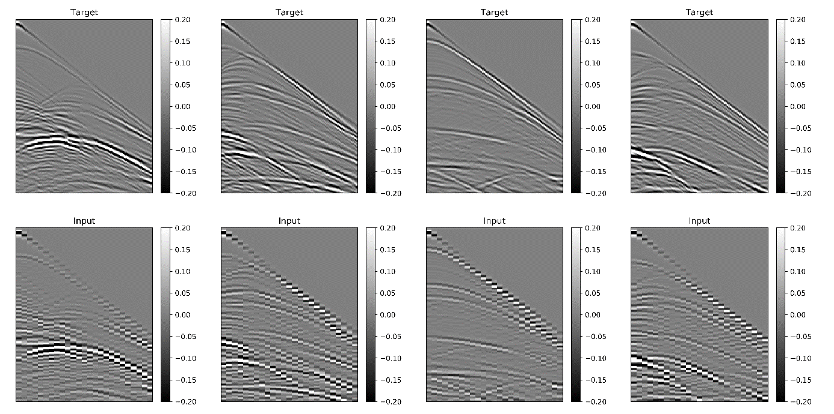

**Figure 1:** The preprocessed target data $y^{HR}$ (top) and their corresponding spatially downsampled version $y^{LR}$ (bottom). The target data were downsampled in the horizontal direction, to $Δx=100 m$ from the original $Δx=25 m$ of the target data.

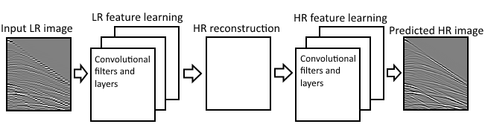

**Figure 2:** A simplified sketch of the CNN architecture. The first part of the network consists of non-linear feature learning directly in LR space from the input ${ y}^{LR}$, before upsampling to HR space in the reconstruction layer. The next part consists of non-linear feature learning in HR space eventually forming the predicted HR image ${\hat{y}}^{HR}$.

The different CNN models filter layout with can be summarized below

$$Method:convolutional layer=\left\{Horizontal filter size, Vertical filter size,Number of filters\right\}$$

$SbCNN:Conv1=\left\{9,9,64\right\}→Conv2=\left\{3,3,64\right\}→Conv3=\left\{3,3,64\right\}→SubPix→Conv5=\left\{3,3,128\right\}→Conv6=\left\{3,3,64\right\}→Conv7=\left\{3,3,1\right\}$

$TpCNN:Conv1=\left\{9,9,64\right\}→Conv2=\left\{3,3,64\right\}→TransposedConv=\left\{3,3,1\right\}→Conv4=\left\{7,7,128\right\}→Conv5=\left\{3,3,64\right\}→Conv6=\left\{3,3,1\right\}$

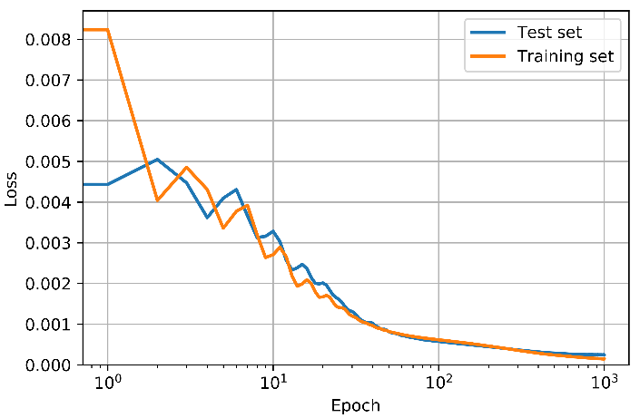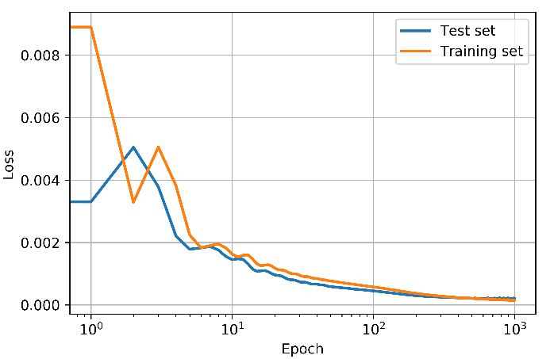

**Figure 3:** Computed loss vs epochs using SCNN. We see that the loss is decreasing, and moving towards convergence at >800 epochs. The training set loss starts of at a higher value, but there is a crossing at around

**Figure 4:** Computed loss vs epochs using TCNN. We see that the loss is decreasing, and moving towards convergence at >800 epochs. The training set loss starts of at a higher value, but there is a crossing at around. The loss for this method decreases more rapidly than by using SCNN, but they converge towards similar loss and R2 score.

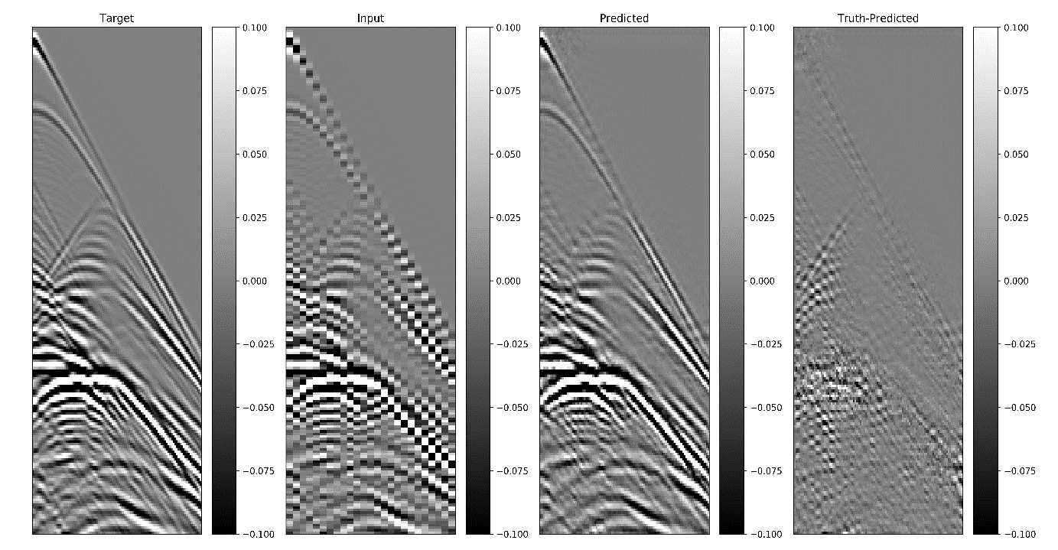

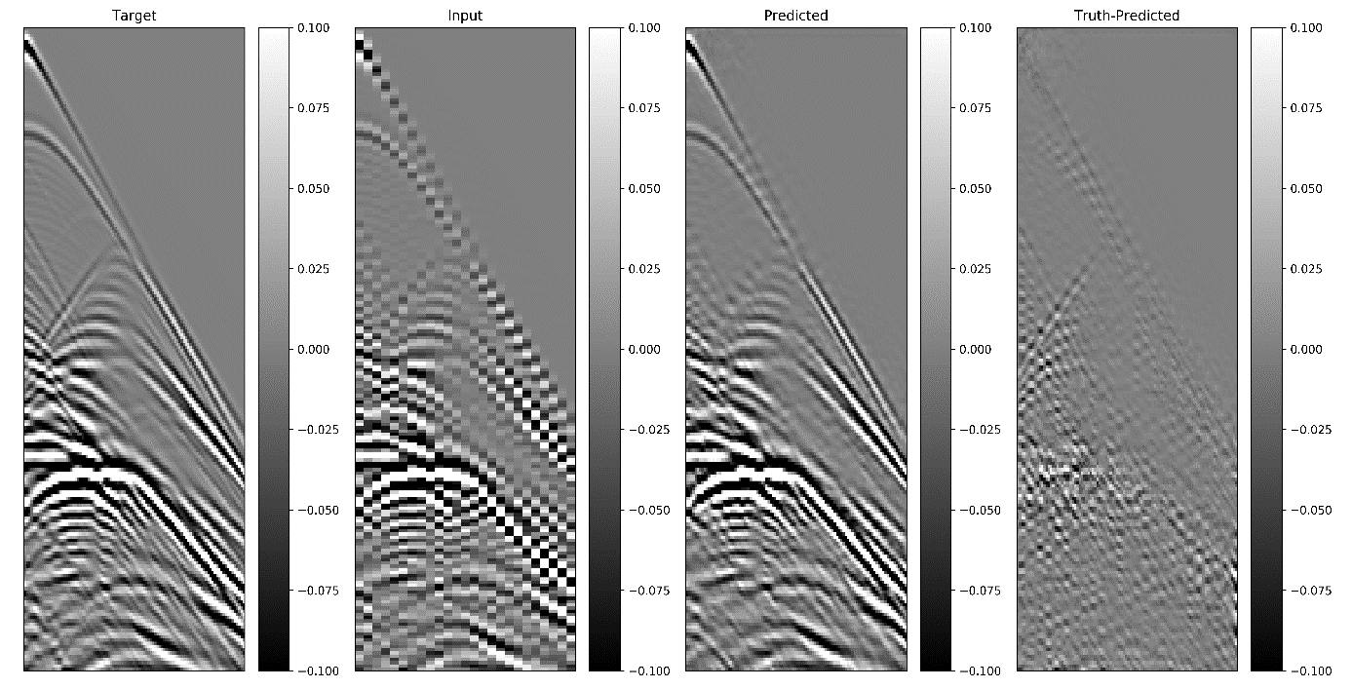

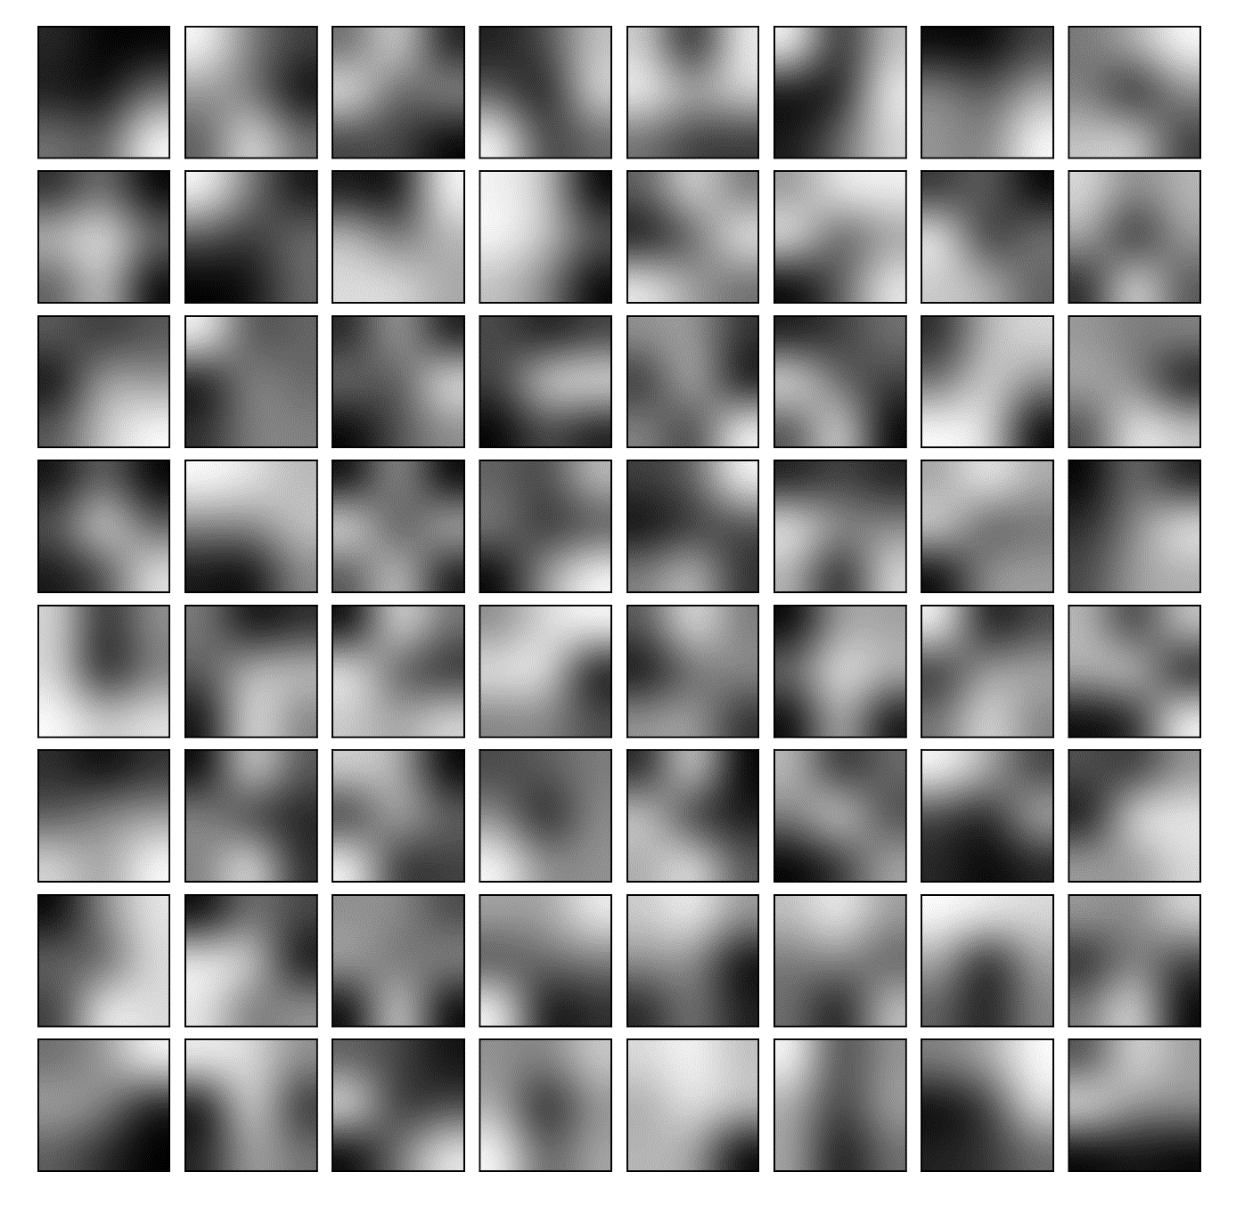

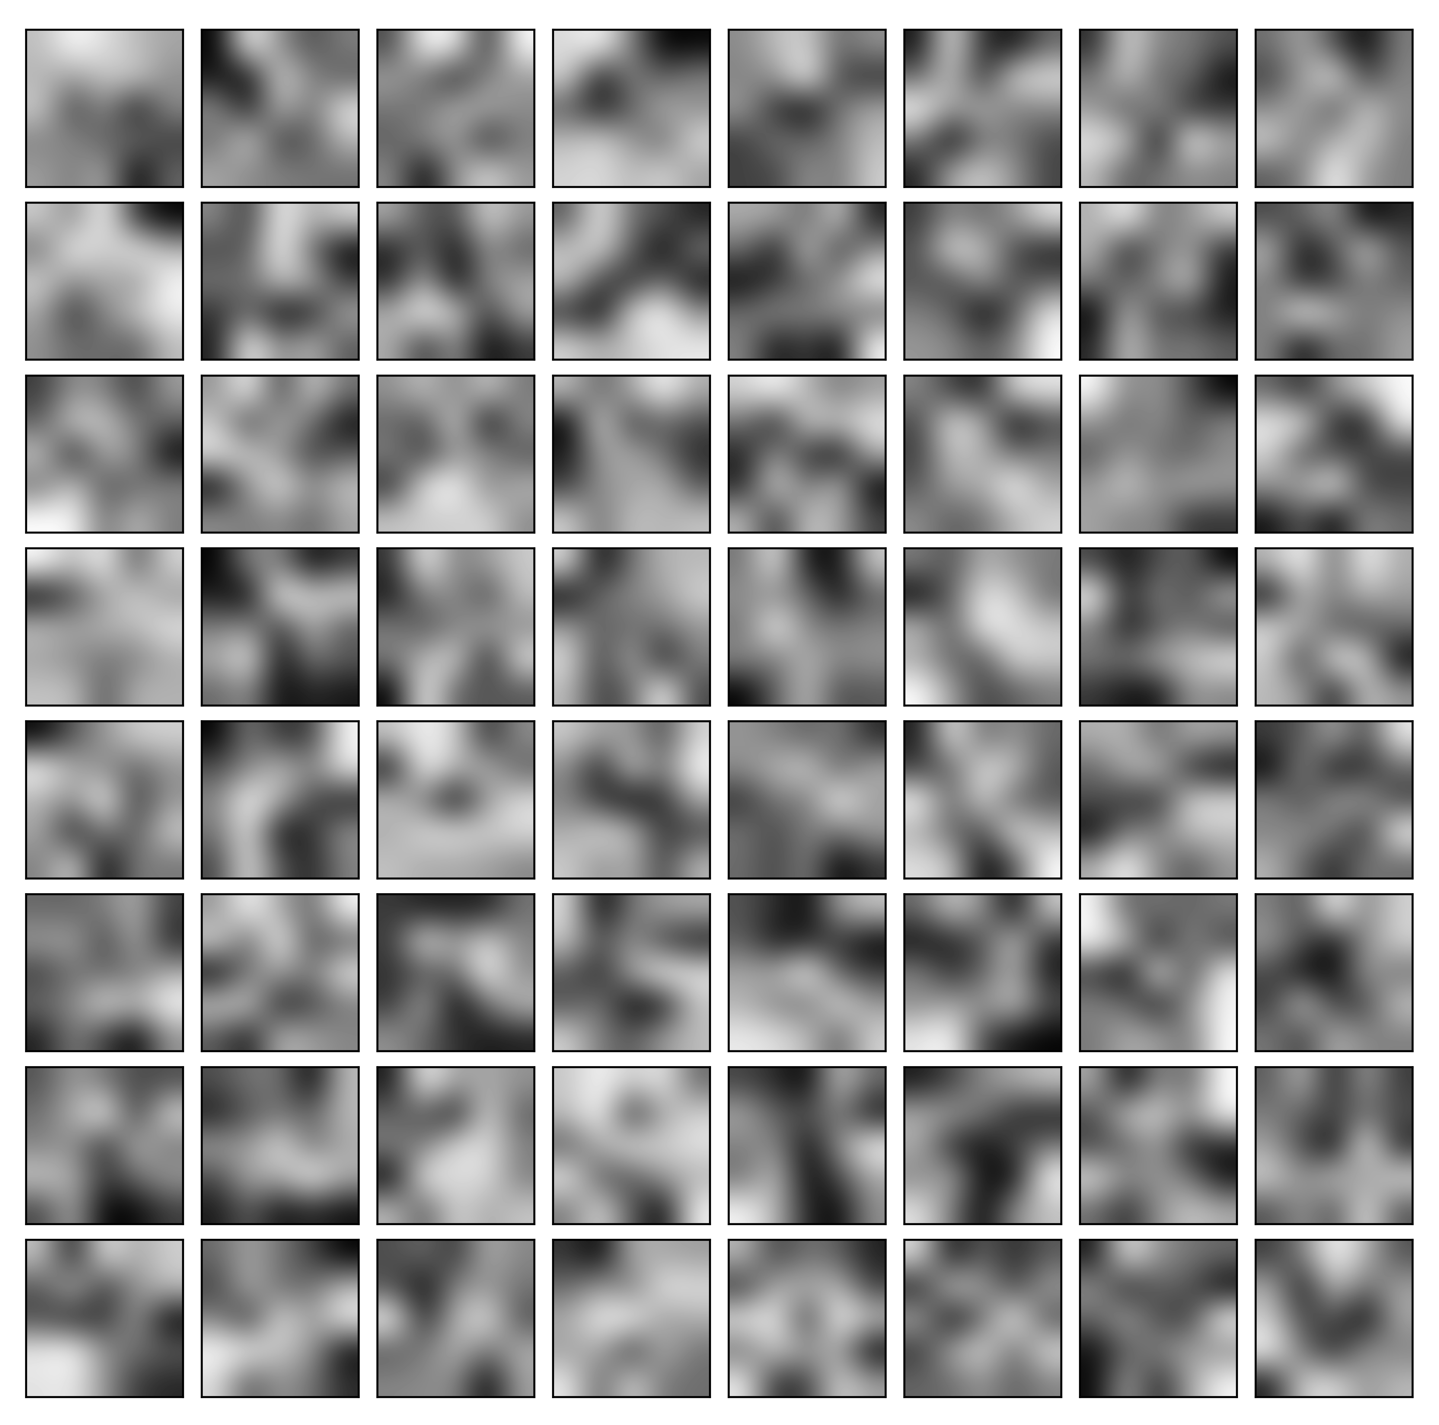

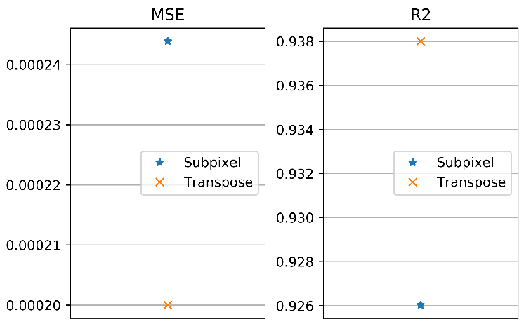

**Mean PSNR**

**Subpix 36.90**

**Transpose 35.52**

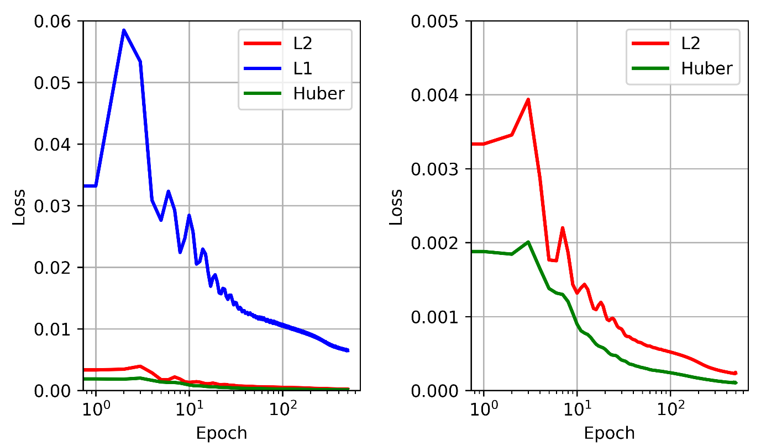**Subpix optimizers**

**Adad = 27.77 Adam = 36.84 Adag = 26.57**

**L2 = 37.49 L1 = 38.59 Huber = 37.63**

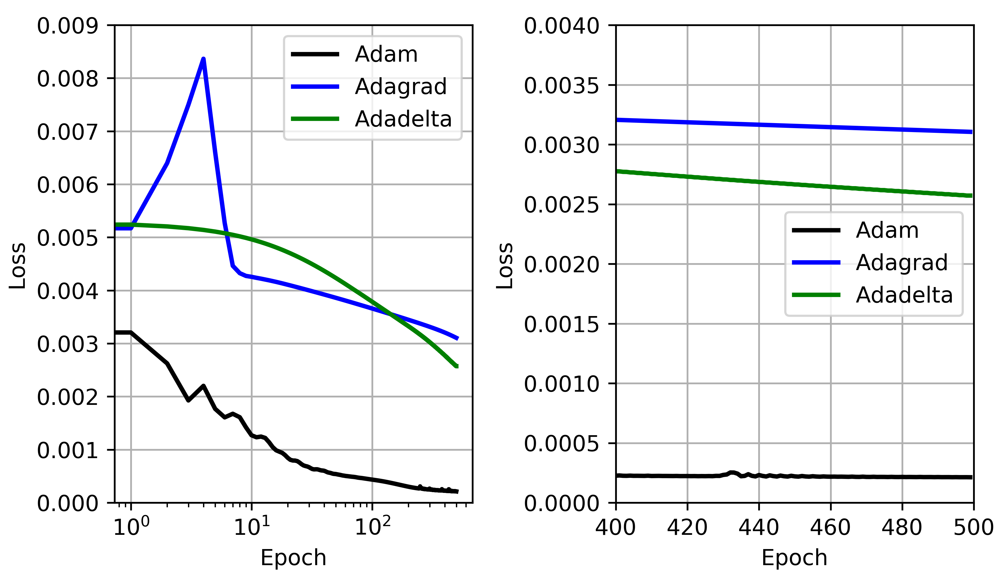

**References**

Dumoulin, V. and Visin, F. (2016). *A guide to convolution arithmetic for deep learning,* arXiv:1603.07285

Etgen, John and Regone, Carl (1998). *Strike shooting, dip shooting, widepatch shooting – Does prestack depth migration care? A model study.* SEG Technical Program Expanded Abstracts 1998: pp. 66-69.